Curriculum Vitae 2025
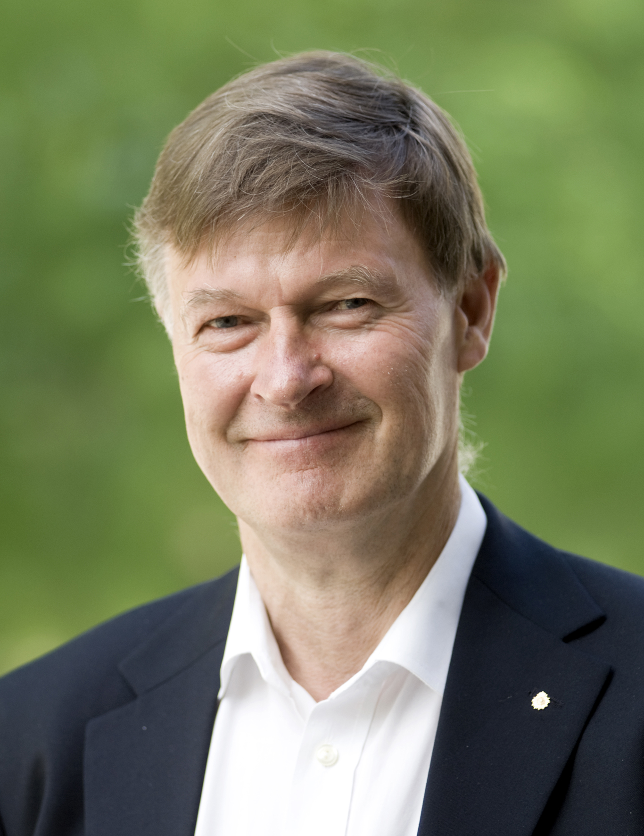
PERSONAL INFORMATION
Family name: Nordén, First name: Bengt
Researcher orcid: 0000-0002-7946-200X
Nationality: Swedish
URL home page: https://research.chalmers.se/person/norden

EDUCATION
University of Lund, Sweden: 1971 PhD in Inorganic Chemistry; 1968 M.Sc in Mathematics, Theoretical Physics and Chemistry (Magna cum Laude).

CURRENT & PREVIOUS POSITIONS
Emeritus Chair Professor of Physical Chemistry of Chalmers University of Technology, Gothenburg. The Chair Professorship of Physical Chemistry of Chalmers University of Technology, Gothenburg, 1979- (appointment by Swedish Government). Appointment per yearly renewed contract with Chalmers University of Technology since 2015. Retired 2025.
Associate Prof (Docent) of Inorganic Chemistry at University of Lund 1972-78; Acting Chair Professor of Inorganic Chemistry, University of Lund 1978. Leave of absence for military service 1972. Sabbatical leaves: Visiting Professor of Oregon Univ. Eugene (with John Schellman) and Univ. Utah (with Josef Michl, 1978), Copenhagen Univ. 1990 (Ole Buchardt), California Institute of Technology 2004 (Ahmed Zewail).

RESEARCH PUBLICATIONS & GRANTED PATENTS
Some 500 publications and textbooks. Citations: 32191. h-index= 93, h-10 index = 366.
Inventor of gene-targeting molecules including the peptide nucleic acids (PNA).

SUPERVISION OF GRADUATE STUDENTS AND POSTDOCTORAL FELLOWS
PhD’s with BN as main advisor: 40 (15 women), of whom 9 now full professors in Sweden or abroad and 2 elected (1 woman) to the Royal Swedish Academy of Sciences.
Postdoctoral Fellows with BN as main advisor: 15.

TEACHING ACTIVITIES
Examiner of courses in the Chemical Engineering Curriculum: Quantum Chemistry (1980-1989), Physical Chemistry (1980-1989), Advanced Biophysical Chemistry (1984-2005). Since 2012 no teaching duties.

INSTITUTIONAL RESPONSIBILITIES
Head (Prefect) of Dept of Physical Chemistry 1981-1991; Dean of Chemistry Section 1985-86.

COMMISIONS OF TRUST
Member of the Royal Swedish Academy of Sciences’ Class that awards the Nobel Prize for Chemistry.
Founder and Chairman of the Molecular Frontiers Foundation, a global organization hosted by the
Academy with two objectives: (1) to early on identify breakthroughs in science and (2) to stimulate young people’s and society’s interests in science by entry through molecular sciences, 2005 – see www.molecularfrontiers.org .
Chairman of the Nanyang Technology University Research Council (supervising research proposals to the Minister of Education; contributed to selection and recruitment of many outstanding scientists over 17 years and other achievements that have contributed to make NTU a top ranked university).
Editor-in-Chief of the Quarterly Reviews of Biophysics (2006-) and of QRB Discovery (2020-2025)
Chair of the ERC’s Panel of Physical and Engineering Sciences for Synergy Grants 2018, 2020.
Chair of European Research Council’s Panel PE4 for Starters Grants (2015 and 2017).
Member of the Nobel Committee for Chemistry 1995-2004
Chairman of the Nobel Committee for Chemistry 2000-2004
Member of the Prize Committee of the Millennium Technology Prize (Finland) 2006-2008.
Member of the Board of Trustees of the Nobel Foundation 2004-2010.
Director of Linnaeus Excellence Centre “Bioinspired Supramolecular Function and Design 2008-2014
Member of the Board of Directors and Science Advisor of the Hasselblad Foundation 1997-2017
Chairman of the Council of the European Research Councils’ Chemistry Committees 2006-2007.
Member of the Governing Board of the Royal Swedish Academy of Sciences 2003-2009.
Science Counsellor of Science Minister and the Swedish Government 1992-1994.
Chairman for the Swedish Research Council's Chemistry Section 1998-2003.
Chairman of the Committee for Physics, Chemistry and Mathematics of Science Europe (succeeding the
European Science Foundation) representing the Research Councils and Research performing
organisations in Europe, 2012-2015.
Chair of International Science Research Evaluations: Theoretical Chemistry in Sweden (1988),
Synchrotron Research in Sweden (1990), Chemistry Dept. of University of Lund (1989), Chemistry Dept. of University of Copenhagen (2004), University of Karlstad (2005), Chemistry Department of University of Lund (2007), Physical Biology Centre for Ultrafast Science & Technology, Caltech 2008.

HONOURS AND AWARDS
Elected to 12 Academies:
The Royal Swedish Academy of Sciences 1991, The Royal Physiographic Society (Lund) 1992, The Royal Society of Arts and Sciences (Gothenburg) 1984, The Royal Swedish Academy of Engineering Sciences 2005, Academia Europaea 2003, The National Academy of Sciences of Germany (Deutsche Akademie der Naturforscher Leopoldina) 2006, The Swedish Academy of Engineering Sciences in Finland 2006, The Norwegian Academy of Sciences 2007, The Academy of Sciences and Letters of Finland (Societas Scientiarium Fennica) 2008, The Academy of Sciences for the Developing World (TWAS) 2009, The International Academy of Engineering (Russia) 2015
Honorary appointments:
Honorary Anniversary Fellow of the Australian National University (ANU) 1996, Honorary Professor of the University of Sichuan in Chengdu 2006, Honorary Fellow of the Chemical Research Society of India 2009, Honorary Fellow of the Chinese Chemical Society, 2009, Honorary Doctor of Nanyang Technology University awarded by Tony Tan, President of Singapore 2014, Honorary Fellow of the Royal Society of Chemistry (HonFRSC) 2015
Prizes:
The Fabian Gyllenberg’s Prize “for the best chemistry PhD thesis in the past three years” Lund 1972 (the first time the prize was awarded). The Goran Gustafsson’s Prize for Chemistry 1992 (the next biggest Swedish prize, the second time the prize was awarded). The Arrhenius Plaque 1994 (awarded by the Swedish Chemical Society). The King Abdullah University of Science and Technology Award of 2008. The Svante Arrhenius Gold Medal of 2009 (awarded every 5th year to a distinguished Swedish Chemist or Physicist by the Royal Swedish Academy of Sciences). The Chalmers Medal 2018.

OUTREACH & POPULAR SCIENCE
Founder and Chairman of the Molecular Frontiers Foundation (www.MolecularFrontiers.org), hosted by the Royal Swedish Academy of Sciences. The Scientific Advisory Board of MF consists of 32 eminent chemists, molecular biologists, physicists and mathematicians (including 17 Nobel Laureates)

PI has initiated more than 20 international MF symposia, the latest big in Stockholm in 2019 attended by nearly one million scientists and high school students from all over the world, see http://www.molecularfrontiers.org/symposia and https://www.planetearthsymposium.org/

CONFERENCES & CONGRESSES
PI has been invited to or himself initiated and organized over 200 symposia and congresses, latest 7th Chemistry Congress 26-30 August 2018 in Liverpool (Chair of Intl Scientific. Committee).

